Multi-Line Insurance Policy and claims Management System

Milestone 3: Claims Adjuster LWC Dashboard Development (Proof)

TEAM 7 MEMBERS :

NAME : R.HARIHARAN
ROLL NO : 822223104033
NM ID: 89EB08A5DEDC3B48B3349612B3B64218
EMAIL ID : hhariharan708@gmail.com

NAME : T.MUTHAMILSELVAN
ROLL NO : 822223104038
NM ID: 6C4BDAACAD9BB1FB31A47784B2502B96
EMAIL ID : t.muthamil555@gmail.com

Name :C.T.BHUVANESH
ROLL NO :822223104042
NM ID : DB1E37315FFD9B494E546AB8931A54DA
EMAIL ID : bhuvameshthi@gmail.com

Milestone 3: Claims Adjuster LWC Dashboard Development
- Create a robust Apex class (ClaimsAdjusterController) with a method using SOQL to query all Claims owned by the logged-in user, joining related Policy and Customer data. The method must return a custom Wrapper Class listing key metrics.
- Click on setup icon, Right click on developer console, Open the link in new tab
- At the top left corner, click on the file, then click on new, and click on Apex class, Give the name as ClaimsAdjusterController and click on create.
- Paste the following code in the apex class: public class ClaimsAdjusterController {
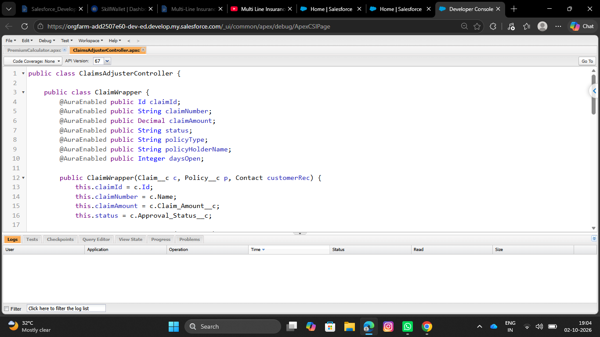
- Save the file using CTRL + S
- This apex class will be handled in the LWC component
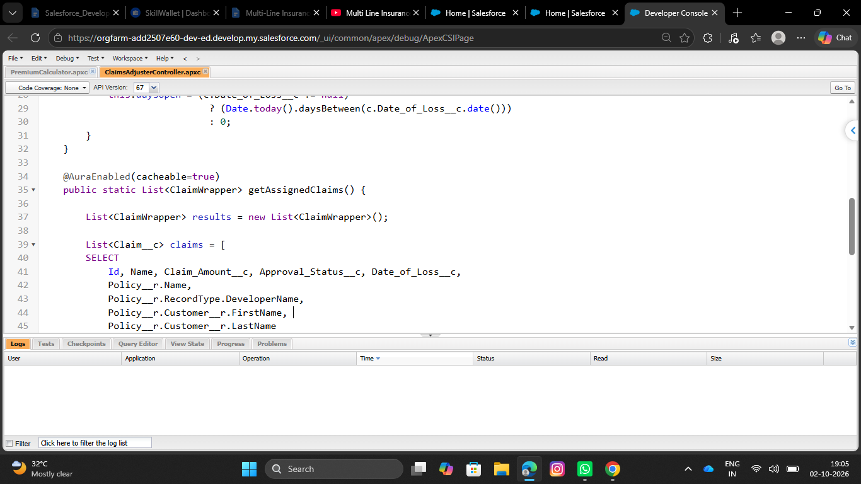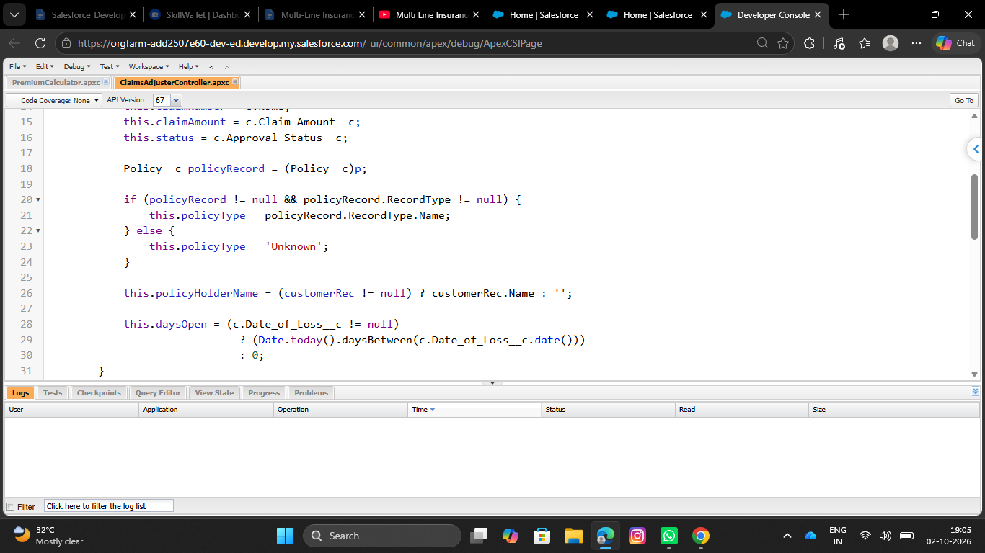
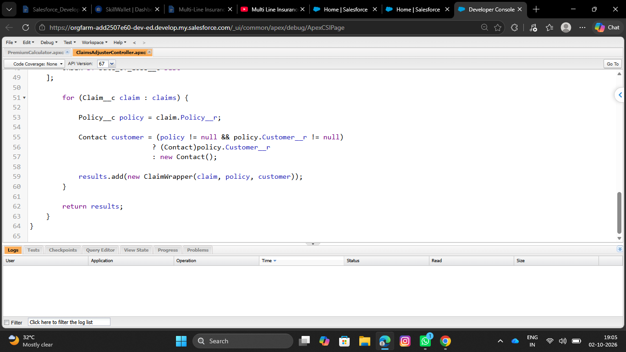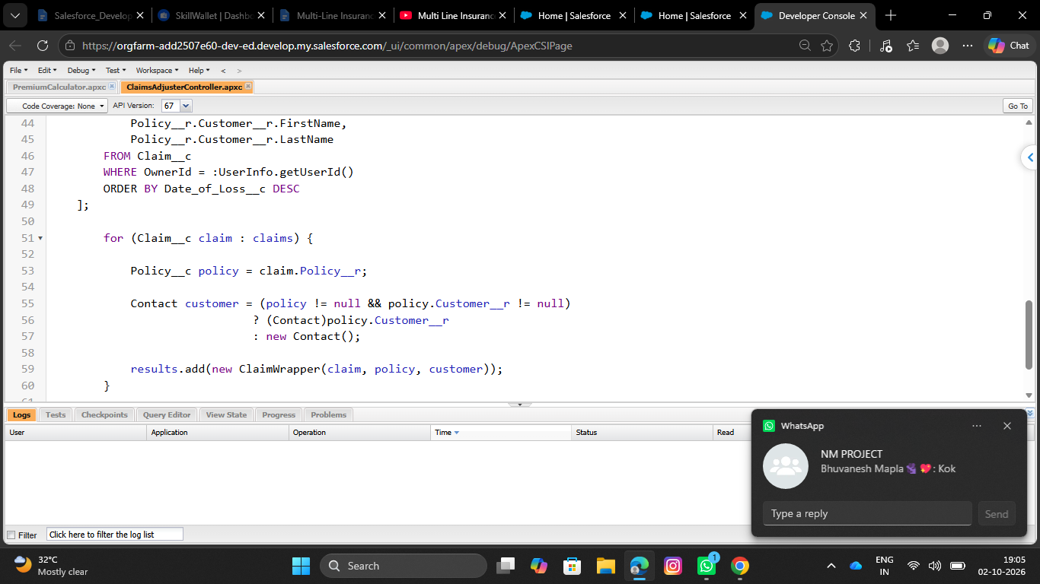2.Create a component (claimsDashboardLwc) that uses the Apex method via the @wire service and implements client-side data filtering
- Open the new tab in chrome and search for lightning studio extension
- Open the first link and click on add to chrome, and confirm by clicking add Extension button
- Now open the Lightning studio extension from your salesforce org
- On the Top left corner, you will find Create New
- Click on Create New and Click on Lightning Web Component
- Enter the name of the Component as claimsDashboardLwc
- Check the isExposed checkbox
- Under target configurations, Select Lightning app page, Home page and Record page
- Click on Deploy
- Open the HTML file and paste the following code:
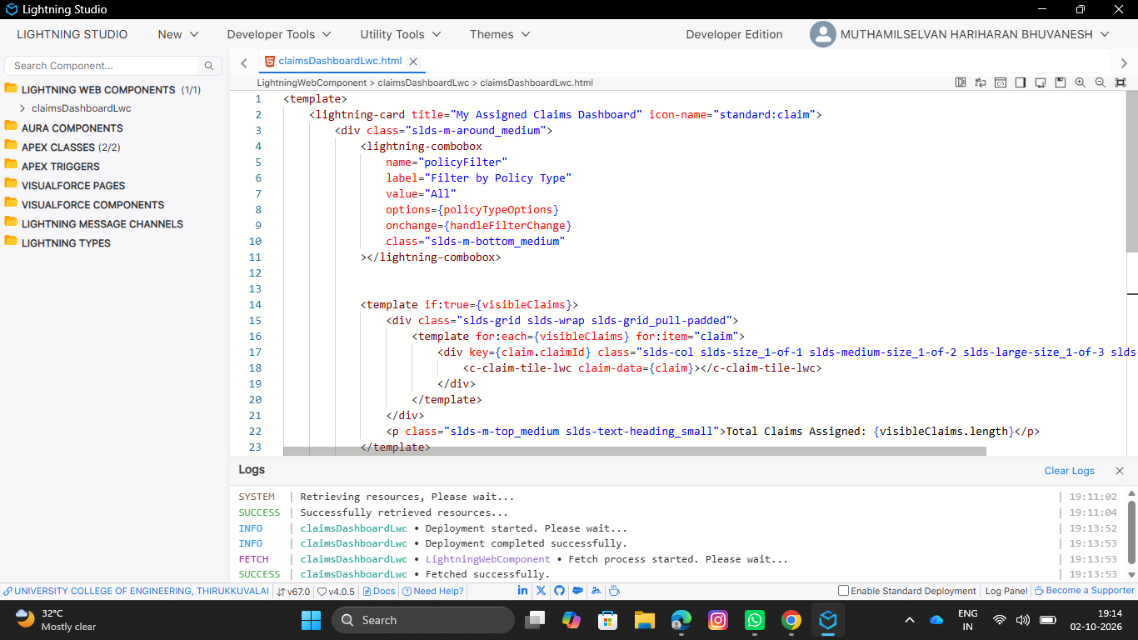
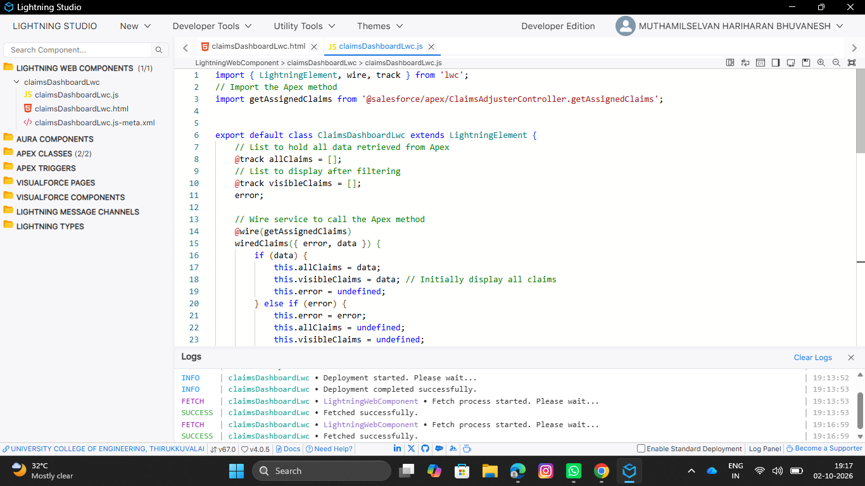

- Open the meta-xml file and paste the following code:

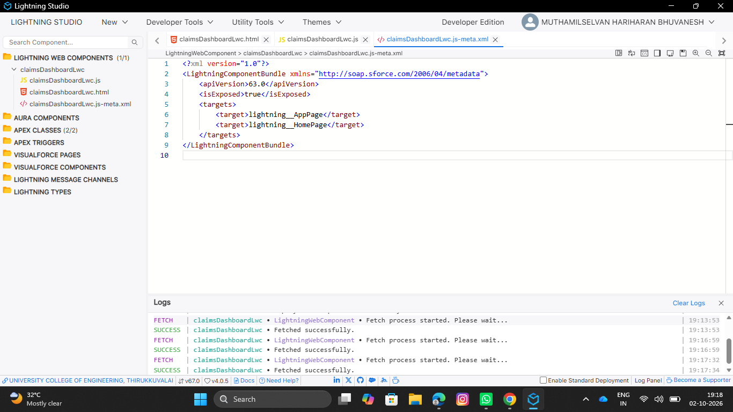3.Create a reusable component (claimTileLwc) to display essential information for each claim
- Open the Lightning studio extension from your salesforce org
- On the Top left corner, you will find Create New
- Click on Create New and Click on Lightning Web Component
- Enter the name of the Component as claimTileLwc
- Check the isExposed checkbox
- Under target configurations, Select Lightning app page, Home page and Record page
- Click on Deploy
- Open the HTML file and paste the following code:

